Experiment No. : 1

Title: Basic Sorting algorithm and its analysis

Batch: B3 Roll No.: 16010422230 Experiment No.: 01

Aim: To implement and analyse time complexity of insertion sort.

Explanation and Working of insertion sort:

Insertion Sort is a simple sorting algorithm that builds the final sorted array one element at a time. It starts with the assumption that the first element is already sorted and then iterates through the remaining elements, inserting each into its correct position within the sorted portion. The algorithm repeatedly compares and shifts elements until the entire array is sorted. Despite being less efficient for large datasets, Insertion Sort performs well on small or partially sorted arrays. Its time complexity is O(n^2) in the worst case, where 'n' is the number of elements.

Let's go through an example with the array [5, 2, 4, 6, 1, 3]:
- Initial state: [5]
- Insert 2: [2, 5]
- Insert 4: [2, 4, 5]
- Insert 6: [2, 4, 5, 6]
- Insert 1: [1, 2, 4, 5, 6]
- Insert 3: [1, 2, 3, 4, 5, 6]

Algorithm of insertion sort:

- Initialization:
  - Start with the assumption that the first element in the array is already sorted.
- Iteration:
  - For each remaining element in the array, starting from the second element (index 1), compare it with the elements in the sorted portion of the array.
  - Move backward through the sorted portion until you find an element smaller than the one you are considering.
- Insertion:
  - Insert the current element into its correct position by shifting the larger elements to the right.
- Repeat:
  - Repeat steps 2 and 3 for each remaining element in the array.
- Final Result:
  - After iterating through all elements, the entire array becomes sorted.

Derivation of Analysis insertion sort:

The total number of comparisons and shifts in the worst case can be modeled as a sum of arithmetic series.
1+2+3+…+(n−1)=n⋅(n−1)​/2

This is the formula for the sum of the first n−1 natural numbers.
The worst-case time complexity is O(n2) in terms of the number of comparisons and shifts.

Best Case Analysis
In the best case, the total number of comparisons is n−1, where n is the number of elements in the array.
The best-case time complexity is O(n) in terms of the number of comparisons and shifts.

Average Case Analysis
The average number of comparisons and shifts for the entire array can be complex to derive precisely due to the varying lengths of the sorted portions and the specifics of the input distribution.
The average-case time complexity is often expressed using asymptotic notation as O(n2) for Insertion Sort, but this is a loose upper bound. The actual average performance may be better, especially for partially sorted datasets.

Program(s) of insertion sort:

import java.util.Scanner;
public class Sorting
{
public static void main(String[] args)
{
Scanner sc = new Scanner(System.in);
int a[];

System.out.println("Enter the number of elements to be sorted:");
int l = sc.nextInt();

a = new int[l];

for (int i = 0; i < l; i++)
{
System.out.println("Enter element no. " + (i+1));
a[i] = sc.nextInt();
}

for (int i = 0; i < l - 1; i++)
{
if (a[i] > a[i + 1])
{
int temp = a[i];
a[i] = a[i + 1];
a[i + 1] = temp;
}
}

System.out.println("The sorted list is:");
for (int i = 0; i < l; i++)
{
System.out.print(a[i] + "\t");
}
}
}

Output(s) of insertion sort:

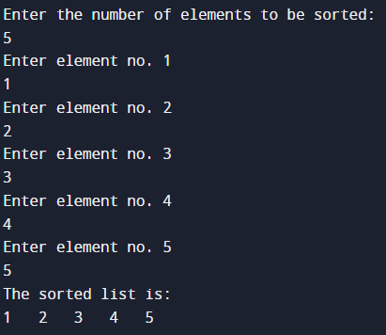
Best Case:

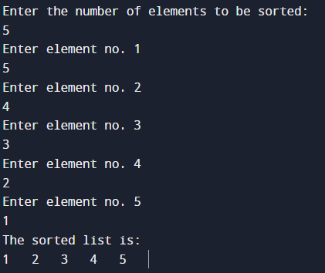
Worst case:

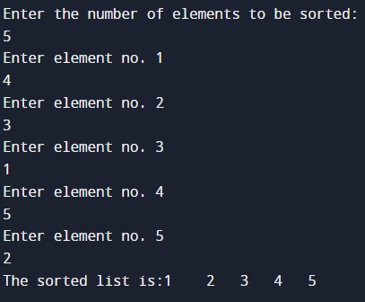
Average Case:

Results:

Time Complexity of Insertion sort:

Worst Case Analysis:

Sr. No. | Input size | No: of steps from Algorithm analysis | No: of steps from Theoretical analysis
1 | 500 | 124750 | 250000
2 | 1000 | 499500 | 1000000
3 | 1500 | 1124250 | 2250000
4 | 2000 | 1999000 | 4000000
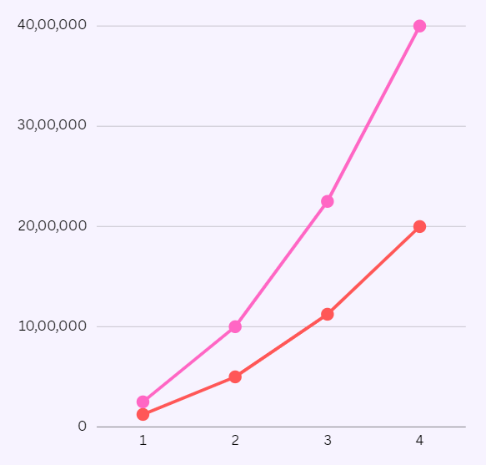
GRAPH:

Best Case Analysis:

Sr. No. | Input size | No: of steps from Algorithm analysis | No: of steps from Theoretical analysis
1 | 500 | 499 | 500
2 | 1000 | 999 | 1000
3 | 1500 | 1499 | 1500
4 | 2000 | 1999 | 2000

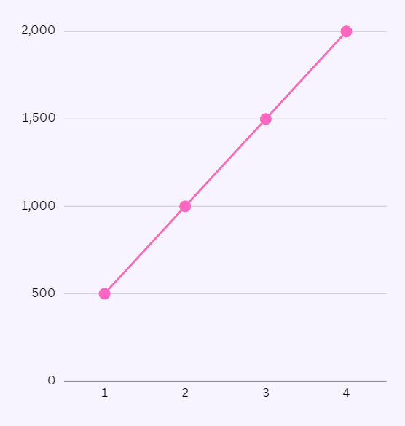
GRAPH

Conclusion: (Based on the observations):
We understood the working of insertion sort and the different cases it has and the relation between theoretical and analytical analysis.

Outcome:
(CO1) Analyse time and space complexity of basic algorithms.

References:
- Richard E. Neapolitan, " Foundation of Algorithms ", 5th Edition 2016, Jones & Bartlett Students Edition
- Harsh Bhasin , " Algorithms : Design & Analysis", 1st Edition 2013, Oxford Higher education, India
- T.H. Coreman ,C.E. Leiserson,R.L. Rivest, and C. Stein, " Introduction to algorithms", 3rd Edition 2009, Prentice Hall India Publication
- Jon Kleinberg, Eva Tardos, " Algorithm Design", 10th Edition 2013, Pearson India Education Services Pvt. Ltd.

